For we are His Workmanship, created in Christ Jesus
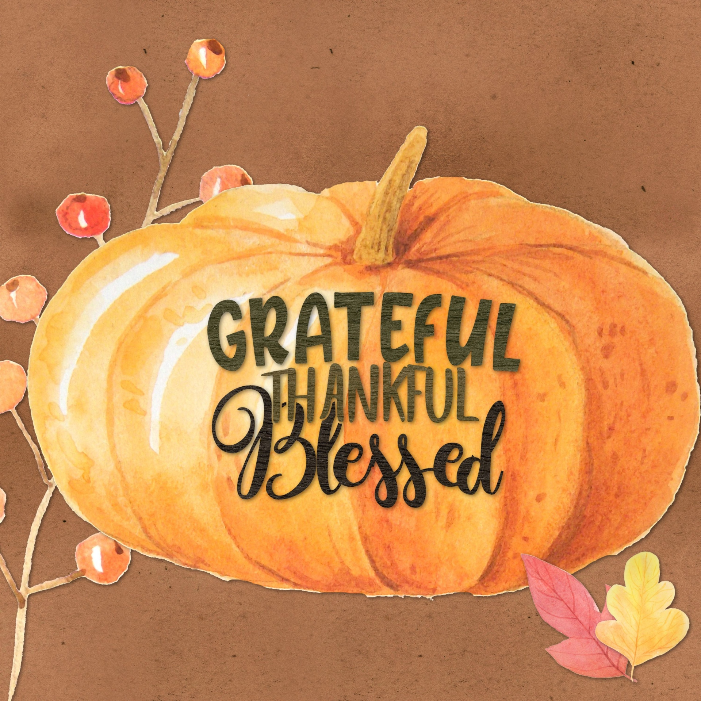
for good works, which God prepared beforehand,
that we should walk in them.
Ephesians 2:10 (ESV)

October 2023 Memo

FROM THE PRINCIPAL

Happy Thanksgiving!
As we move into the month of October, may our hearts be filled with joy and thanksgiving for all that God has done. In Psalm 100:3-5 David writes,
“Know that the Lord, He is God!
It is He who made us, and we are His;
we are His people, and the sheep of His pasture.
Enter His gates with thanksgiving,
and His courts with praise!
Give thanks to Him; bless His name!
For the Lord is good;
His steadfast love endures forever,
and His faithfulness to all generations.
God’s faithfulness towards us reaches to all generations; He is the same yesterday, today, and forever. Paul tells us in Ephesians 2:4-10 that it is through God’s goodness, God’s grace, that we are saved; there is nothing we can do to earn or obtain salvation. We can only receive His gift through faith. As I was reading and preparing for Bible class this week, I was reminded that it is not the quality of my faith or the size of my faith that matters, but rather the quality of who or what I put my faith in. It is not because of my character or strength, but God’s character and strength. I can have faith in a chair, but if that chair is not strong or is compromised; it does not matter how strong or quality of faith I have, the chair will still collapse on me. What a blessed reminder that is! As we enter into this season of harvest and thanksgiving, let us turn our hearts and minds to all that God is doing.

Our school is growing; it is a blessing to see new faces and classrooms full of desks! God is working in our classrooms and in our students. Students are learning to grow in relationship with God and with each other. As a school community, we have wonderful activities to look forward to this month. On October 5th we will celebrate harvest time with “dress like a fruit or vegetable day” and a school wide afternoon activity. Picture day is coming up later this month and the staff are away for professional development and spiritual encouragement from October 18-21st. Please pray that this would be a time of encouragement, fellowship, and that unity would be strengthened during this trip. At the end of the month will be community service, usually we join in with Operation Christmas Child and fill shoeboxes for children around the world.

Give thanks to the Lord for He IS Good!

Ms. Jeffrey

CLASSROOM UPDATES

ECS
In Kindergarten we are starting the year focusing on learning to recognize and write the numbers 1-10 and we are learning the names, shapes and sounds of the alphabet. Socially, we are focusing on playing co-operatively and taking turns listening to what others have to say. Our scientific focus is currently on exploring the five senses.
GRADES 1&2
Fall is upon us and so are cooler temperatures. I love the beautiful colors that God has painted for us.
Please remember to have your children dress appropriately for the weather.
L.A: Grade 1’s will continue to review alphabet sounds, names and formation, and we will be writing
simple sentences with invented spellings. Grade 2’s will begin guided writing on top of sentence and
journal writing. Baggy books will be sent home as soon as reading assessments have been completed.
Just a note – Library class is every Tuesday.
Math: We will be counting to 10 (Grade 1’s) and to 20 (Grade 2’s). Grade 2’s will also start adding and
subtracting, reading and writing number words, and begin solving word problems.
Science: We will continue to work through our unit on Matter. We have been learning about objects,
materials, and how to choose materials for specific purposes.
Social: We are learning about the communities of Iqaluit, Meteghan, and Saskatoon. We are comparing
these communities to High Level, by learning about geography, climates, and how these affect the daily
lives of people living there.
Bible: We are learning about Wisdom and Biblical Truth.

GRADES 3&4
Science- we are currently working on the unit "Waste in our World,"
Social- we are focusing on the 6 geographical regions in Alberta.
Math- grade 3 comparing numbers by place value and in grade 4 adding and subtracting large numbers with the aid of base 10 blocks.
language arts- the focus this month is key word outlining
Bible - we are learning about building up and strengthening our foundation in Christ Jesus, through wisdom given in His Word.

Art - We are experimenting with lines and different types of lines

GRADES 5&6
Social Studies – We will continue to examine the main attributes of democracy and the responsibilities of citizens within democracy.
LA – September focused on genres and introducing the reading challenge for the year; we also began grammar and spelling. October will have a heavy focus on writing complete sentences and paragraphs; reading assessments will be completed.
Math 5- We are continuing with reviewing and building up our knowledge of addition and subtraction skills with larger numbers.
Math 6- We are now venturing into the new world of integers. Learning about negative numbers.
Science – Evidence and investigation unit
GRADES 7-9
Social Studies – we will continue to study the first peoples of Canada, moving from first nations to the British in North America.
LA – We’ve completed our genre study and have begun our short story unit. Students have been assigned a reading challenge for the year.
Math 7- We are finishing up with divisibility rules and our review of fractions.
Math 8- We reviewed prime numbers and factors of numbers.
Math 9- We have been working on square roots and surface area.
Science 7- We are working on the Structures and Forces unit
Science 8/9- We are working on Electrical Principles and Technologies
Bible – we are currently studying the inspiration and history of the Bible, how we still have it today.

IMPORTANT DATES
Oct 5: Dress like a vegetable or fruit day
Oct 6: PD Day – No School
Oct 9: Thanksgiving Day – No School
Oct 18-21: KCES PD Days – No School
Oct 27: Lifetouch Photos – individual photos
Bring your best smiles
Negatives will be sent home later from which parents are able to order various packages directly from Lifetouch. Parents may call 1-866-457-8212 if there are any questions regarding the photos or ordering process.

