High Level Christian Academy
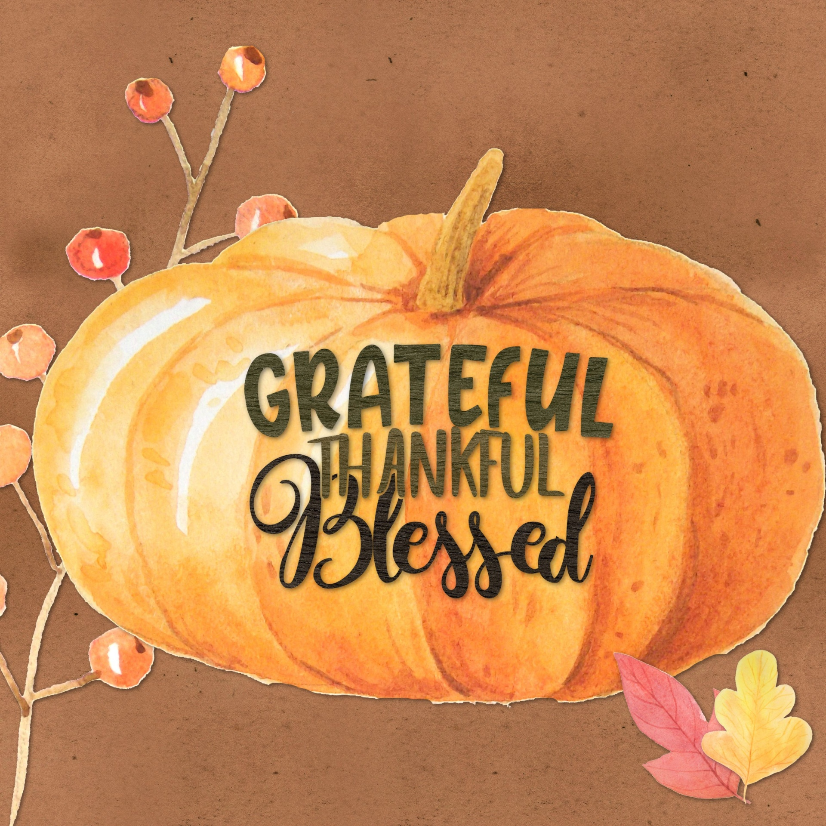

Gratitude

“Give thanks to the God of Heaven. His love endures forever.”

Psalm 136:26

October Memos

FROM THE PRINCIPAL

Happy October!
What a beautiful fall we are having! It has been a blessing to enjoy the lovely fall leaves much longer into the fall. I love the fall; God’s creation is breathtaking! September was a busy month with multiple long weekends and our Koinonia Conference. It was such a blessing as a staff to be gathered once again as a larger community; it was the first time since October 2019! We have a few things to look forward to in October; it will be “Dress like a Scarecrow Day” on the 14th and picture day on the 21st. I am excited to see the creative outfits students will come up with!
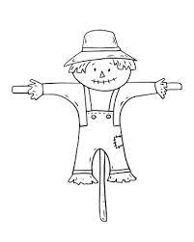
As we turn our hearts and minds to Thanksgiving next weekend; I pray that your hearts will be filled with gratitude for all that God has done and is doing. I find it greatly humbling to pause and list all that God is doing within our school, our staff, and our community. God is always at work; I pray that we have the eyes to see His work. I am reminded of Simeon and Anna in Luke 2 who patiently fasted and prayed that they would see the Messiah before their deaths; they were ready when the Holy Spirit led them to the temple the day that Jesus was presented in the temple. They did not doubt and knew God was working out His plan in His timing and not theirs. May we continue to watch and pray as God carries out His will in our school.
Have a blessed Thanksgiving!
Alisa Jeffrey

CLASSROOM REMINDERS AND ANNOUNCEMENTS

ECS – GRADE 1
I can’t believe we have already had a whole month of school. We’re all settling into routine and learning
lots of new things every day.
LA: Grade 1’s: Spelling tests have started. Weekly lists will be sent home and glued into your child’s
agenda. Please keep an eye out for it every Monday. Test dates are on the bottom of each list and the
entire weekly spelling lists are all located in your child’s B.E.E. folder in case you cannot find it. To help
your child with the words, please have them practice breaking them up into their phonemes or sounds.
We will also be practicing spelling words in class.
Please remember to sign and record times and books in the reading log (Baggy Books). I only expect
students to read on school days. Please encourage your child to read by having them point to each word,
breaking words into letter sounds as well as using pictures to prompt/guide them. We have been and
will continue to write sentences with word family and sight words, in our journals. Guided reading has
started in class and will continue.
ECS: We have completed our first Jolly Phonics book and are working on the second book. We have also
started with drawing to read and write, and will continue with this as we learn more letters and can use
them to make more words. We will also continue to practice breaking words into sounds as we hear
them in our Jolly Phonics books.
MATH: Grade 1’s: We are focusing on Number Sense this month, counting to 10 and counting strategies
to 20. We will also be writing, comparing, and ordering numbers; using terms such as more than and
fewer than.
ECS: Our focus this month is on numbers 1 to 5. We will be identifying, counting and writing these
numbers. We will also learn about comparing numbers using greater than and less than, and practice
identifying them.
SOCIAL STUDIES: This month’s focus is belonging in our world. Students are developing an
understanding and appreciation of identity and self-esteem, and learning to figure out how they belong
or fit in their world; family, school, community, and other groups. We have been and will continue to learn about what it means to be unique and how God has created us all as individuals with different talents, giftings and abilities.

SCIENCE: Grade 1’s: The unit we are studying is “Creating Color”. We will be exploring color in natural
and manufactured objects. We will also learn to sort color by shade, mix colors, and explore how colors
can be transparent and opaque.
ECS: Themes we will touch on through discovery are Fall, apples, color and senses. We will also continue
this in November.
BIBLE: This month’s focus is on faith. Our focus verse is Philippians 4:13.
HEALTH: We are learning about making healthy relationship choices, as well as how to be a good friend.
Students will learn about how to demonstrate responsibility, show respect and care for others. We have
been learning about the Zones of Regulation and will continue with these throughout the year.

GRADES 2 - 3
Language Arts: Reading Logs have been coming home nightly along with a leveled reader. Students are asked to read for 10 minutes each night, Monday through Friday. Please encourage your child to complete this every night, having them read out loud to you. There is a letter to Parents in the reading Log, be sure to check it out! Spelling tests are happening every Friday.

Math: The first unit of Math (Patterns) is drawing to a close. Math quiz results will be coming home soon. Our next unit for both grades 2 and 3 is Number Sense, with a focus on place value.

Science: Our first unit Exploring Liquids is going well. We should be finishing up this unit by the end of the month.

Social: We are learning about Communities in Canada – Iqaluit, Saskatoon, and Meteghan. We are examining the land and climate, comparing it to where we live in Alberta.

Bible: Learning about how God called Abraham and what it means to live in obedience to God.
I would like to wish all families of HLCA a very happy and blessed thanksgiving!

GRADES 4-6
Math – The grades 4-6s are finishing their units on place value and representing numbers; the grade 4s will then begin a unit on multi-digit addition and subtraction and looking at mental math strategies for quick calculations; they will then begin a unit on multiplication. The Grades 5s and 6s will wrap their unit on place value and move directly into multiplication and division.
Science – We will continue with our unit on Waste in Our World; the students have been learning about biodegradability, recycling, re-using and rethinking waste. We will be looking at using things that are safer on our environment. We will be wrapping the unit up this month. We will finish the unit with a large project that will require containers and items we usually toss into the trash or recycling.
Social - In September we focused on mapping both Canada and Alberta. We learned about cardinal directions and got familiar with our textbook. We will begin our first unit on the various geographical regions in Alberta. We will examine their geographical features, their natural resources, and the quality of life for Alberta’s habitants.
LA – September was spent assessing student reading levels, introducing the reading challenge, writing assessments, and setting up our various books and journals. Students will begin their reading groups this month, they will focus on sentence and paragraph structure. Our regular learning activities include typing, word work, spelling, reading groups, and writing instruction.

GRADES 7-9
Math - The Gr 7s will be wrapping up their chapter on divisibility and factoring; they will then begin their chapters on fractions and then decimals. The Gr 8s will wrap their chapter on perfect squares and cubes; they will also be studying fractions but will move into ratio and rates after. The Gr 9s will complete their chapter on powers and exponents; they will be learning about rational numbers next. The gr 9s will then turn their focus to polygons.
Science – The Gr 7s will be learning about Structures and forces. The Gr 8s will be learning mix and flow of matter. The Gr 9s will be looking at Biological Diversity.
Social – We spent the month of September focusing on mapping and world events (both the passing of Queen

Elizabeth II and Mikhail Gorbachev). We finished September looking at individual and collective identity. We will be learning about the structure of our federal government and how its structures and processes work to meet the needs of all Canadians. We will then take a closer look at the Justice branch of our governing system.
LA – Gr 7s will be looking at short stories. Gr 8 and 9 are learning about non-fiction and visual communication.
Bible – The students will wrap up the introduction with an exam and will then begin their unit on Biblical sociology. This unit examines God’s designs for spheres of authority, of family, church, and state. Students will recognize that God establishes authority differently than the world.

GENERAL INFORMATION:

ALLERGIES/MEDICAL
There are no peanut allergies this year. There are some gluten free student, lactose free students as well as an egg allergy. Please check with your teacher before bringing in class snacks so we can accommodate this. Please let us know if there are other allergies that we should be aware of.

HOT LUNCHES
A hot lunch will be offered every Thursday. Order forms will be sent home with the monthly memo. Please ensure the orders are in at least 2 days before hot lunch day.

ATTACHMENTS
- Monthly Calendar
- Hot Lunch Order Form

CUTLERY/UTENSILS
The school WILL NOT be providing any cutlery to students except for hot lunch. The students MUST bring their own. We suggest they always have a set in their backpacks or lunch kits.

WATER
There will be a water cooler in the hallway available for students to fill up their water bottles just as we had last year. The water fountain is functional also for students that forget to bring their water bottles.

VISITOR SIGN-IN
Please report at the office by signing in before proceeding to any classroom.

STUDENT PICKUP
The afternoon dismissal time is 3:25pm. All students must either walk home or be picked up by a parent or guardian. If someone other than the parent or guardian is picking up a student, the school must be notified prior to dismissal time. A note in the student’s agenda or a call to the school work well for notifying the school.

STUDENT SIGN-IN
Please stop by the office to sign your child "in" if you are dropping them off after 8:50am or "out" if you are picking them up throughout the day before 3:25pm. This will assist us in knowing which children are on site.

NEWSLETTERS – MEMOS
Each month the youngest child in the family will bring home the Memos with attachments for the coming month. Please take time to read the newsletter to keep yourselves informed of the upcoming expectations and activities.

SOCIAL MEDIA
Please check out our website @ www.hlcacademy.ca for upcoming events and information. HLCA has a Facebook group. Its purpose is to be an additional source of information for parents, supporters and alumni to keep up to date on current events at HLCA. It is a supplement to our school newsletter. If you wish to have something posted, (information, encouragement, praise/prayer) please contact the school. Essentially, it is like an electronic billboard. Questions, comments, and concerns need to come to the school by way of phone, text, email or in person. Questions related to your child's class are best communicated by phone, text, email, or a note in your child's agenda.

IMPORTANT DATES
Oct 10: Thanksgiving No School
Oct 14: Dress like a scarecrow Day
Oct 20: Progress Reports Go Home
Oct 21: Lifetouch Photos – individual photos taken Bring your best smiles
Photos will be taken on Oct 21st and negatives will be sent home later from which parents are able to order various packages directly from Lifetouch. Parents may call 1-866-457-8212 if there are any questions regarding the photos or ordering process.
Oct 25: Operation Christmas Child Shoeboxes
The classes will each be doing shoeboxes. There will be more information to follow.

(HLCES) UPDATE FROM THE BOARD:
On Schoology in the HLCA Parents group is an open discussion forum for asking questions of the board; Ms. Jeffrey will be notified when a question is posted and will seek a response from a board member.

Board Members are:
- Shawn Wiebe – Chairman
- Ray Lapka – Vice Chair and Secretary
- Troy Kidder - Treasurer
- Jerry Krahn – Fundraising
- Josh Clark - Maintenance
- Suzanne Wolfe - Member

The little caesars orders will be arriving at the school during the week of October 17th.

FUNDRAISING EVENTS

PURDY’S
We are participating in the Purdy’s Chocolates Fundraising program again. This is a great fundraiser for HLCA as we receive a percentage of sales, according to the total amount of all orders. This is open to everyone; therefore, you are encouraged to avail this opportunity to family, friends or neighbors! Two catalogues and order forms will be sent home this week.

FUNDSCRIP
The High Level Christian Academy is enrolled in a fundraising program called FundScrip. This is a program where supporters use gift cards to pay for things that they are going to buy anyway, such as grocery, gas, restaurant, and household item expenses. By simply changing your method of payment for everyday spending, the school will receive a percentage of the sales. We encourage families to take advantage of this fundraising opportunity to help HLCA raise funds for operation. The cards are available at the office and are payable by cash, debit, credit, and e-transfer. Please call the office if you have any questions.

