High Level Christian Academy
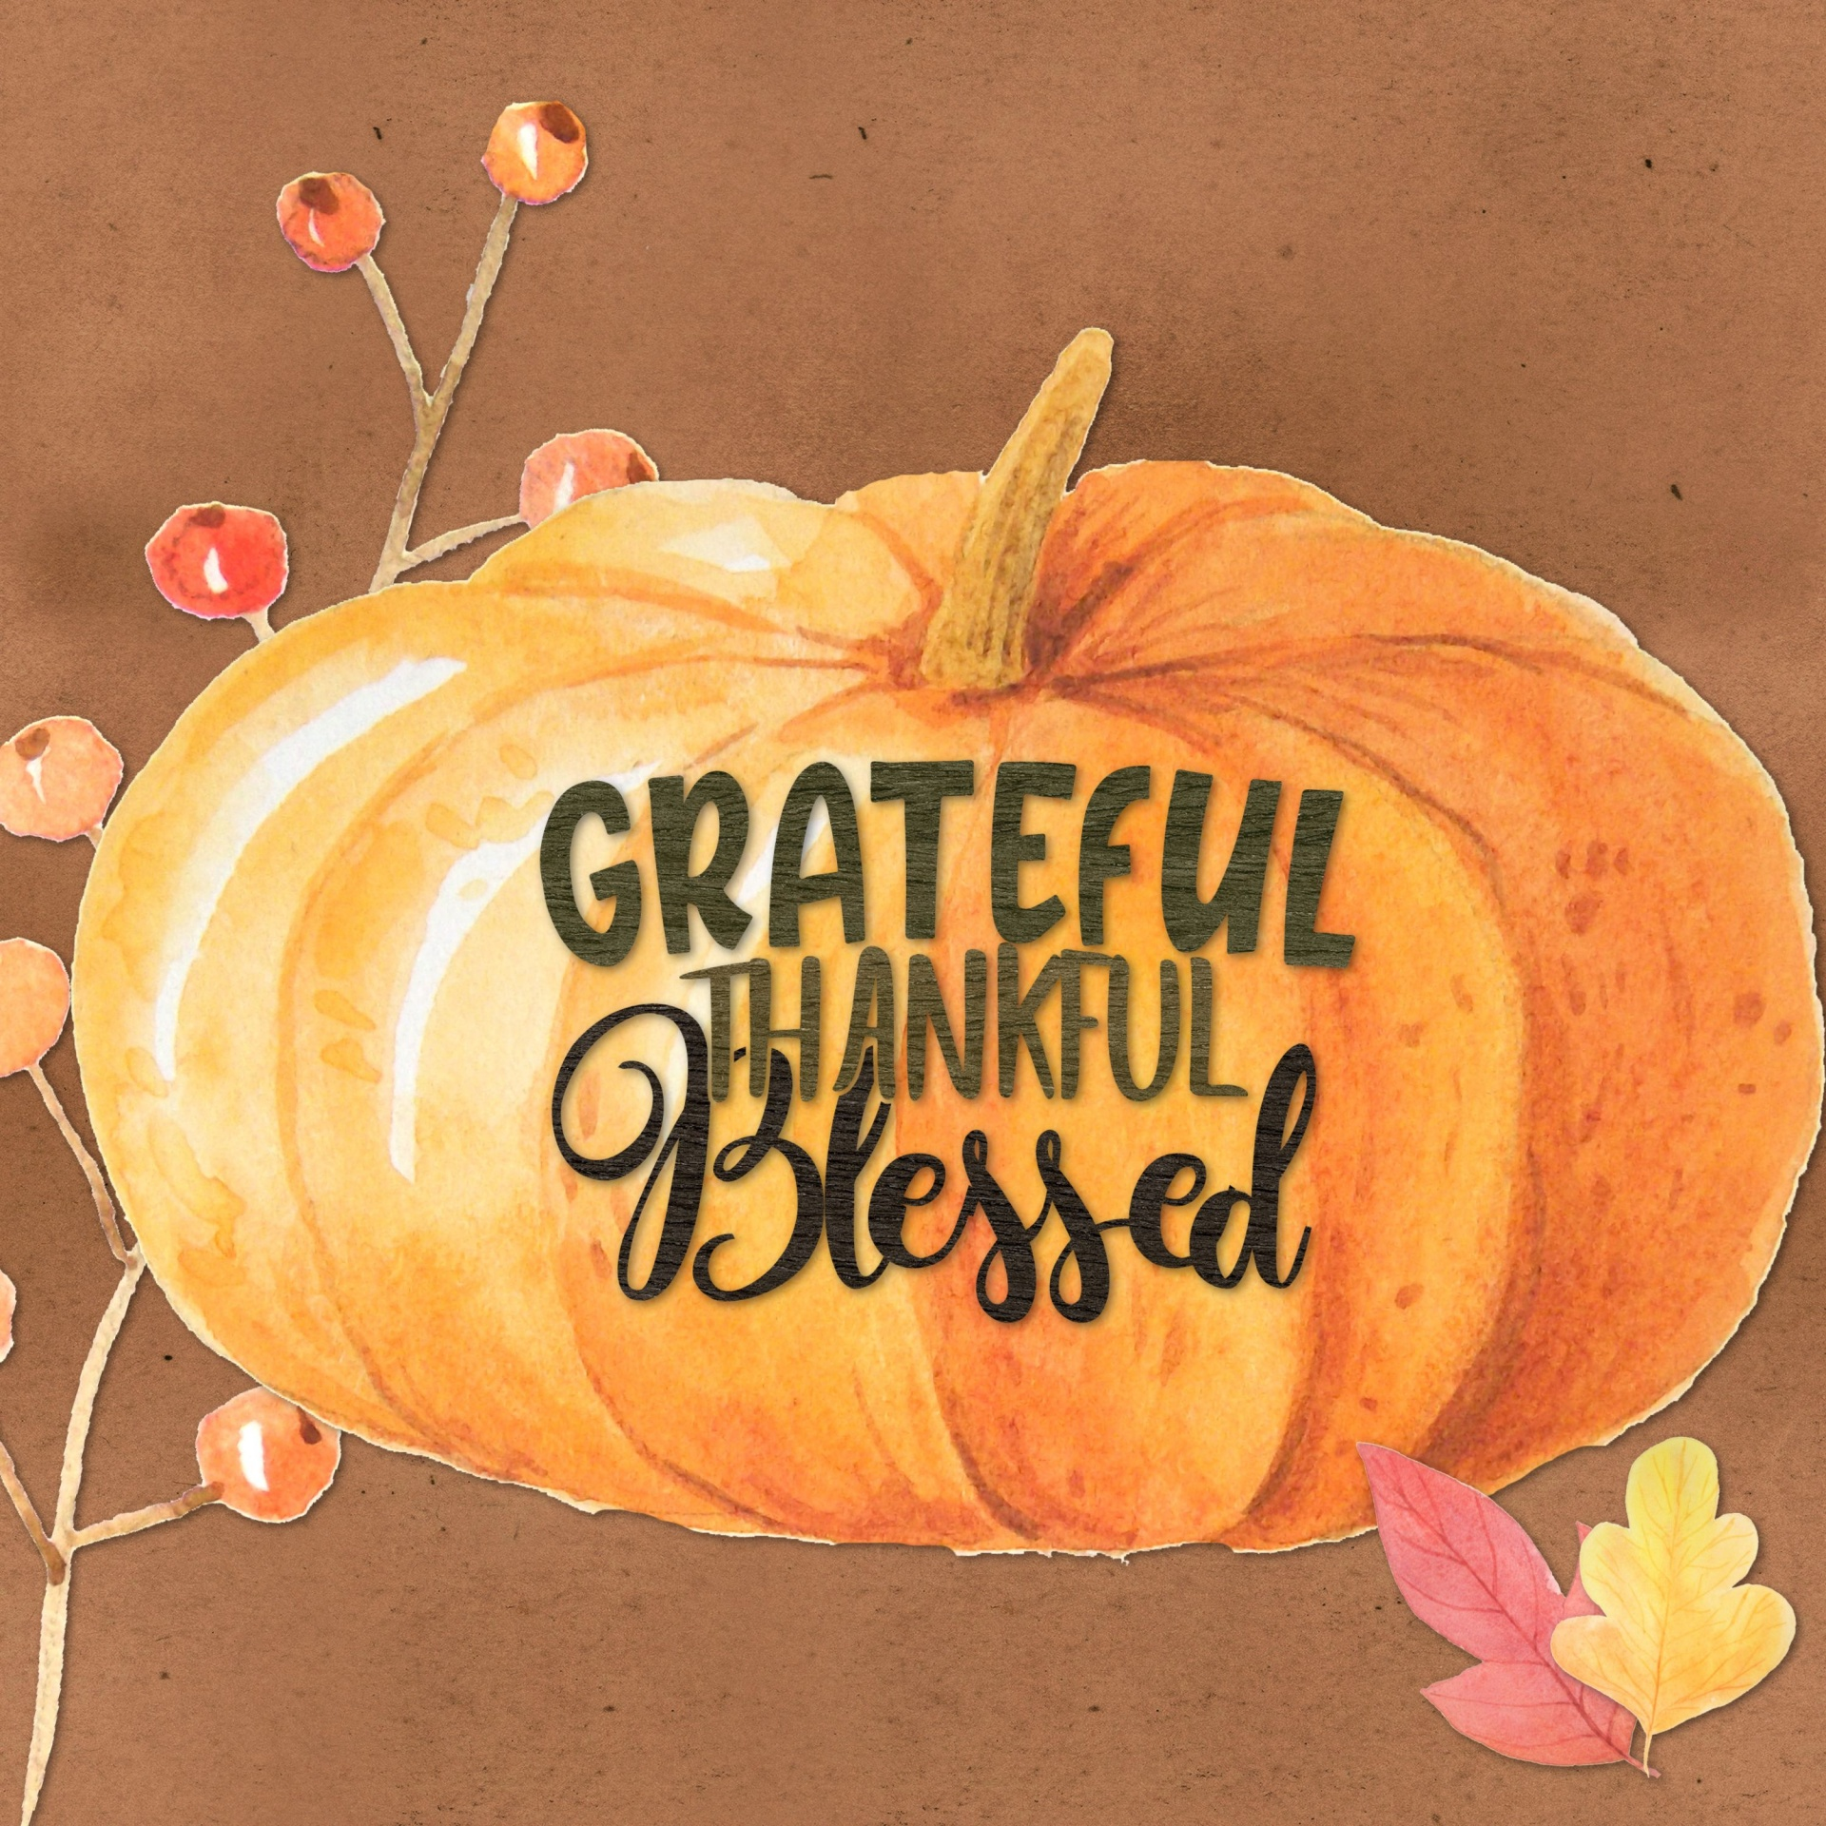

“THE JOY OF THE LORD IS MY STRENGTH”

“Nehemiah said, “Go and enjoy choice food and sweet drinks, and send some to
those who have nothing prepared. This day is holy to our Lord. Do not grieve, for the joy of the Lord is your strength.”

Nehemiah 8:10

October Memos
FROM THE PRINCIPAL
Give Thanks to the Lord for He is good!
September has been a busy month; lots happened and much has changed from September 1st to October 1st. I am so thankful for all that we were able to do in September even with the increasing restrictions. We had a wonderful track and field day; I am so thankful for Shawn Wiebe and Joe Gerbrandt who headed the planning and the day. We have been blessed with a variety of chapel speakers already and I know our students will benefit greatly this year from their teaching! We welcomed two new staff members to the HLCA team: Connie Gerbrandt and Emily Wolfe. These ladies have been a blessing in our school already; Emily Wolfe is assisting Mrs. Brock in the office and Mrs. Gerbrandt is the Educational Assistant in Mrs. Bartlett’s classroom. HLCA was able to participate in Terry Fox Day and the students each gave generously and participated joyously! Finally, the weather was beautiful and attitudes cheerful on Friday October 1st for our first community service of the year.
The fall season is my favorite! While the changing colors and cool fall breezes certainly fill my heart with joy, I love the fall season because of Thanksgiving. Many might find fall a sad time of year because the plants are either dying or going dormant for the winter, and the growing signs that winter is coming. I believe, however, that this is the perfect time to stop and give thanks. It is easy to be thankful when life is new, things are getting better, and the sun is shining, in the times of spring and summer. It is a far greater challenge to choose to give thanks when there is death, darker days, and decay, in the fall and winter times. David understood the importance of giving thanks and rejoicing in the Lord; his psalms are full of expressions of sadness and pain followed by declarations of the greatness of God. David chose to rejoice in the greatness and goodness of God throughout the trials and triumphs of his life. Paul reminds us in Philippians and in other epistles the importance of giving thanks. He writes in 1 Thessalonians that we should “rejoice always; pray without ceasing; in everything give thanks; for this is God’s will for you in Christ Jesus.” (1 Thess. 5: 16-18) Paul writes this in both Philippians and Thessalonians in the context of standing firm in the faith. Giving thanks in anxious times, rejoicing in the Lord always; this is what strengthens our hearts and brings light and joy to the dark days. May we all “give thanks to the Lord for He is good; His love endures forever” (Ps 118:1) and “taste and see that the LORD is good.” (Ps 34:6)

God is good ALL the time!

Alisa Jeffrey

CLASSROOM REMINDERS AND ANNOUNCEMENTS

ECS – GRADE 1
Thank you for your support in helping the students learn spelling words and Bible verses at home. I hope everyone enjoys Thanksgiving and gives thanks to God and count the blessings He abundantly provides for us.
Starting this month, classroom reading challenge will be implemented to encourage reading at home. Reading is very important for developing your child’s brain, ability to focus and communication skills. There will be a reading log sent home for each student. Please record the title, author and minutes spent reading the book. Also, please initial to confirm the information. For Kindergarten, I would encourage the parents to read out loud to the child so students can be taught comprehension strategies. For Grade 1, I encourage parents to ask a child to read the book to you to enhance decoding and comprehension skills. To encourage comprehension, please ask the child what happened in the story to check his/her understanding of the story.
To motivate students, I will be creating a chart to record the number of minutes each student has spent reading on a bulletin board. The snowman for each student will move on the chart as according to the reading log minutes. The goal is to reach 500 minutes of reading for grade 1s or 250 minutes of reading for kindergarten students in October. If a student reaches this goal by the end of October, the student will get to keep the snowman as a souvenir! For confidentiality, the snowman will be assigned a letter, not labelled with a name.
If you would like to borrow books from the classroom library shelf, the students can take out labelled books. They must return the borrowed book before taking out a new one. Thank you!
Grade 1 Math: We are learning about number sense; how to compare numbers by using math terms such as more than and less than.
Kindergarten Math: We are learning about number sense. This month, Kindergarten students will be learning about counting to 20. Students will review number concepts such as greater than and less than.
K/1 Science: We are doing the Colour Unit. Students are learning about how to make light and dark shades of primary colours and are exploring how to make mystery colours.
Grade 1 Social: We have been learning about the Migration of First Nations and their ways of survival. We will be learning about the origin of their agriculture, languages and traditions.

GRADES 2 - 4
This month kicks off our classroom reading challenge – Read Across the World. For every 20 minutes read, students will earn 300kms towards an imaginary trip. The trips coincide with each of the four countries we have been learning about in Social Studies plus a couple of bonus trips! Trip number 1 is from Calgary to Ottawa. And from Ottawa will be our springboard to adventures all around the world! Students can read alone, read to someone and even have others read to them, those minutes count too! If you can’t get all 20 minutes in in one night, you can split it over 2 days, the goal is continuous reading to earn the kms. needed. There is a letter to Parents coming home in the reading Log, be sure to check it out!

Spelling tests are happening every Friday. I will send these books home at the end of the month for you to see and sign. Please help your child remember to return them the next day. There are NO spelling words for the week of Oct. 4-8. Spelling will resume after the break.

Our first unit of Math (Number Sense) is drawing to a close and we will be having a Math Test soon.

I would like to wish all families of HLCA a very happy and blessed thanksgiving!

GRADES 5-6
LA: We’ve begun our novel, Wonder by R. J Palacio; please keep your child from watching the movie while we are reading the novel. We will continue with spelling, grammar, and word work throughout our novel study unit. Each student in grade 5/6 has a 50 book reading challenge that they should continue to work on.

Math: The whole class will begin new units after the break, both groups will be focusing on patterns and algebra, by the end of the month we will be moving into multiplication. Please continue to review the multiplication tables with your student; I recommend making a game out of it.
Science: We will finish our Evidence and Investigation unit. The students have been learning about various types of evidence from fingerprints, to handwriting samples, and footprints. They will wrap up the unit with a large crime scene project.

Social Studies: We will continue to look at democracy and its basic foundations in Canada. Later this month, we will begin to look at ancient Athens as our first historical model of democracy in history.

GRADES 7-8
Math: The grade 7s have been looking at analyzing data using mean, mode, median, and range; they will wrap up this unit this week. The grade 8s have been reviewing many number concepts focusing on fractions in the last few weeks. Both the grade 7s and 8s will begin looking at patterns and algebra after the break. They will focus on pattern rules, writing algebraic expressions, identifying the dependent and independent variables, and evaluating algebraic equations with given values for multiple variables.

LA: We have begun our novel study of The Bronze Bow by E. G. Speare; we will examine plot, conflict, characterization, and themes. We will continue with weekly vocabulary; students are tested each week on 8-10 words. They are required to use the word correctly in a sentence, spell the word correctly, and use correct sentence structure (capitalization and punctuation). Each week the grade 7/8s are also given a grammar rule to practice. The grade 7/8s have also been given a 100 book challenge; they are encouraged to keep reading a variety of texts from a variety of genres.

Science: Gr 7: Studying structures and forces.
Gr 8: Studying the mix and flow of matter.

GRADES 7-9
Social Studies: We have begun looking at the origins of the western worldview that came out of the European Renaissance. We are wrapping up chapter one which described what life was like in the Middle Ages, moving into the 14th and early 15th centuries. We will next study the expansion of trade and its impact on the economy in Europe as well as its impact on exploration. By the end of October, we should also begin examining the growth of humanism and reason during the Renaissance.

Bible: We will begin looking at the Biblical Christian worldview of Theology. What they believe about God is the foundation or the root to all the other branches in our Biblical Christian worldview. What we believe about God impacts everything else from the origins of life to the purpose of government. Please look for ways to discuss with your students about this topic of Theology.

GENERAL INFORMATION:

ALLERGIES/MEDICAL
Please let us know if any of your children have any allergies or medical concerns, we need to know about so we can best accommodate them.

HOT LUNCHES
A hot lunch will be offered every Thursday. Order forms will be sent home the last Monday of the month for the following month. Please ensure the orders are in at least 2 days before hot lunch day.

ATTACHMENTS
- Monthly Calendar
- Hot Lunch Order Form
- Purdy’s Catalogues and Order Forms

CUTLERY/UTENSILS
The school WILL NOT be providing any cutlery to students except for hot lunch. The students MUST bring their own. We suggest they always have a set in their backpacks or lunch kits.

WATER
There will be a water cooler in the hallway available for students to fill up their water bottles just as we had last year. The water fountain is functional also for students that forget to bring their water bottles.

VISITOR SIGN-IN
Please report at the office by signing in before proceeding to any classroom. Scan the COVID-19 health check list posted on the entrance door before entering the building.

STUDENT PICKUP
The afternoon dismissal time is 3:25pm. All students must either walk home or be picked up by a parent or guardian. If someone other than the parent or guardian is picking up a student, the school must be notified prior to dismissal time.

STUDENT SIGN-IN
Please stop by the office to sign your child "in" if you are dropping them off after 8:50am or "out" if you are picking them up throughout the day before 3:25pm. This will assist us in knowing which children are on site.

NEWSLETTERS – MEMOS
Each last Monday of the month the youngest child in the family will bring home the Memos with attachments for the coming month. Please take time to read the
newsletter to keep yourselves informed of the upcoming expectations and activities.

SOCIAL MEDIA
Please check out our website @ www.hlcacademy.ca for upcoming events and homework. HLCA has a Facebook group. Its purpose is to be an additional source of information for parents, supporters and alumni to keep up to date on current events at HLCA. It is a supplement to our school newsletter. If you wish to have something posted, (information, encouragement, praise/prayer) please contact the school. Essentially, it is like an electronic billboard. Questions, comments, and concerns need to come to the school by way of phone, text, email or in person. Questions related to your child's class are best communicated by phone, text, email, or a note in your child's agenda.

IMPORTANT DATES
Oct 6-8: PD Days No School
Oct 11: Thanksgiving No School
Oct 21: Lifetouch Photos – individual photos taken Bring your best smiles
Photos will be taken on Oct 21st and negatives will be sent home later from which parents are able to order various packages directly from Lifetouch. Parents may call 1-866-457-8212 if there are any questions regarding the photos or ordering process.

(HLCES) UPDATE FROM THE BOARD:
On Schoology in the HLCA Parents group is an open discussion forum for asking questions of the board; Ms. Jeffrey will be notified when a question is posted and will seek a response from a board member.

Board Members are:
- Shawn Wiebe – Chairman
- Ray Lapka – Vice Chair and Secretary
- Cecil Lebbi – Treasurer
- Jerry Krahn – Fundraising &
Maintenance
- Suzanne Wolfe

FUNDRAISING EVENTS

LITTLE CAESARS PIZZA
This fundraiser is happening now; please order online before October 11. Orders are due in the office by October 13th.

PURDY’S
We are participating in the Purdy’s Chocolates Fundraising program again. This is a great fundraiser for HLCA as we receive a percentage of sales, according to the total amount of all orders. This is open to everyone; therefore, you are encouraged to avail this opportunity to family, friends or neighbors! Two catalogues and order forms are attached. The order forms are no longer in the catalogues as online customers do not require them. You may order online or submit the order form with payment to the office. If you need more catalogues or order forms, they are available in the office. Please call Jane Gerbrandt @780-926-2828 if you have any questions. The deadline to order is Tuesday, November 16th to ensure the chocolates arriving at the beginning of December.

FUNDSCRIP
The High Level Christian Academy is enrolled in a fundraising program called FundScrip. This is a program where supporters use gift cards to pay for things that they are going to buy anyway, such as grocery, gas, restaurant, and household item expenses. By simply changing your method of payment for everyday spending, the school will receive a percentage of the sales. We encourage families to take advantage of this fundraising opportunity to help HLCA raise funds for operation. The cards are available at the office and are payable by cash, debit, credit, and e-transfer. Please call the office if you have any questions.

HIGHLIGHTS & HAPPENINGS

Let the 4-Square games begin!
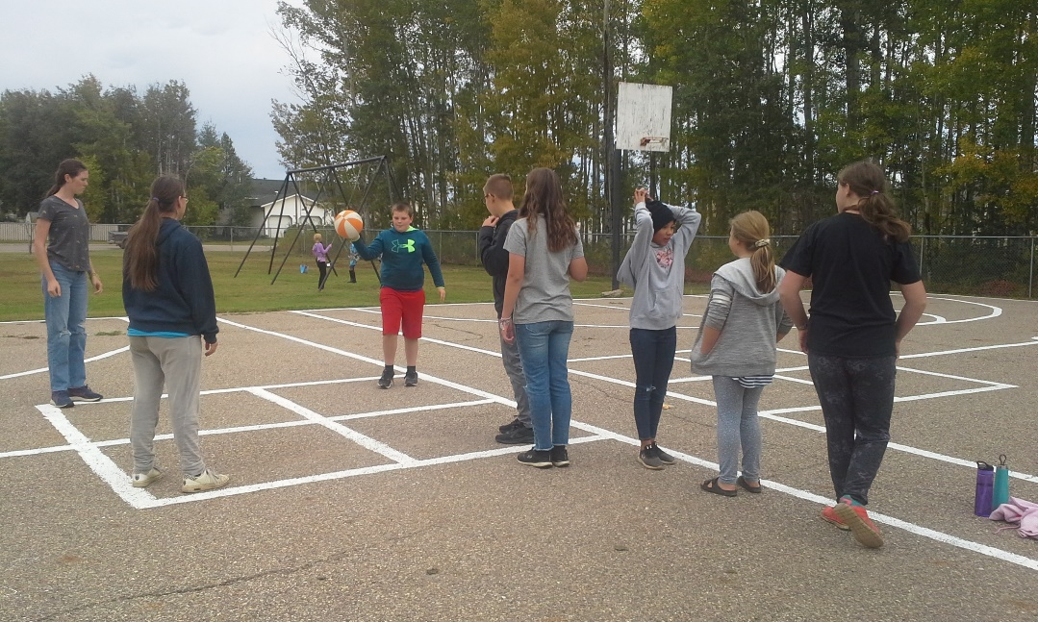

Track & Field
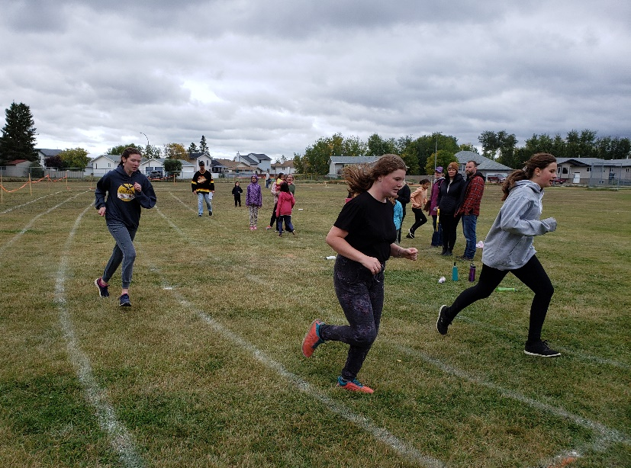
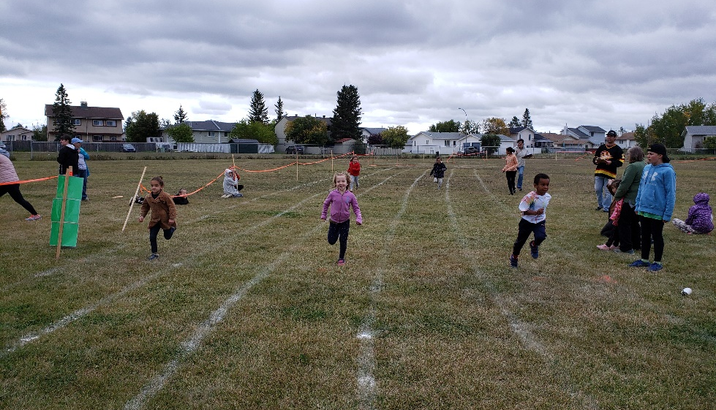

September Community Service – raking leaves

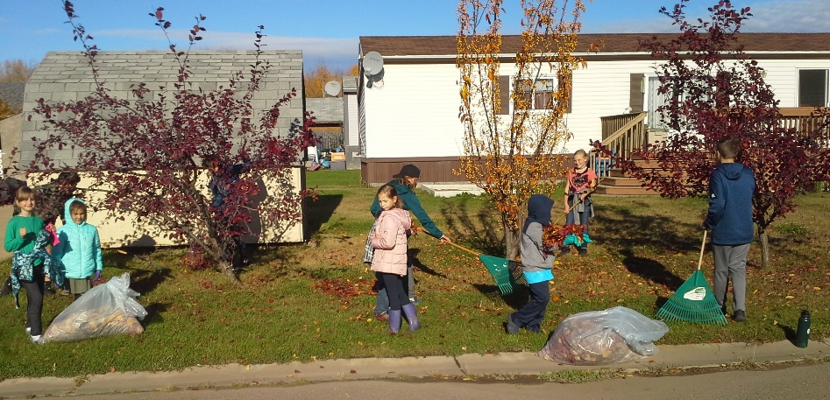

Enjoying the playground activities!
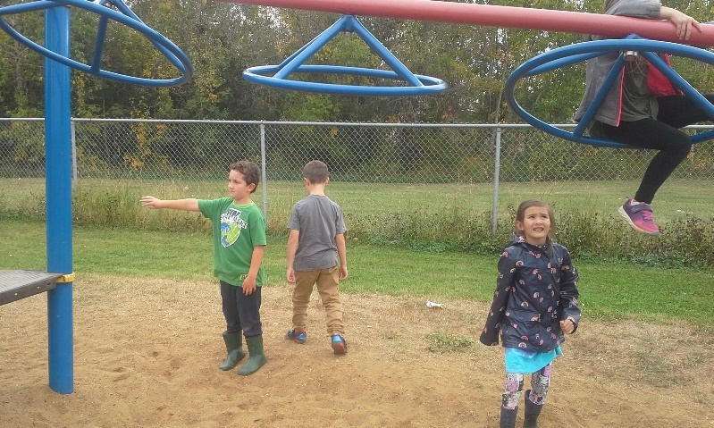

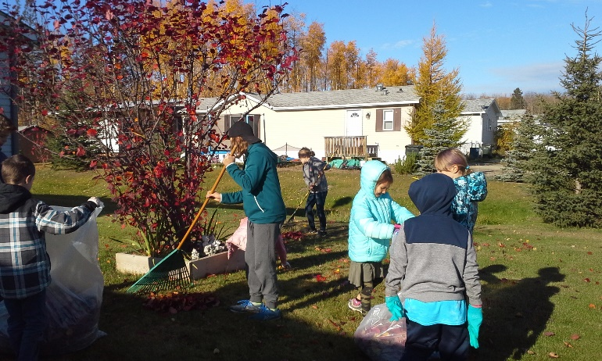

Terry Fox Run/Walk

Terry Fox Run/Walk
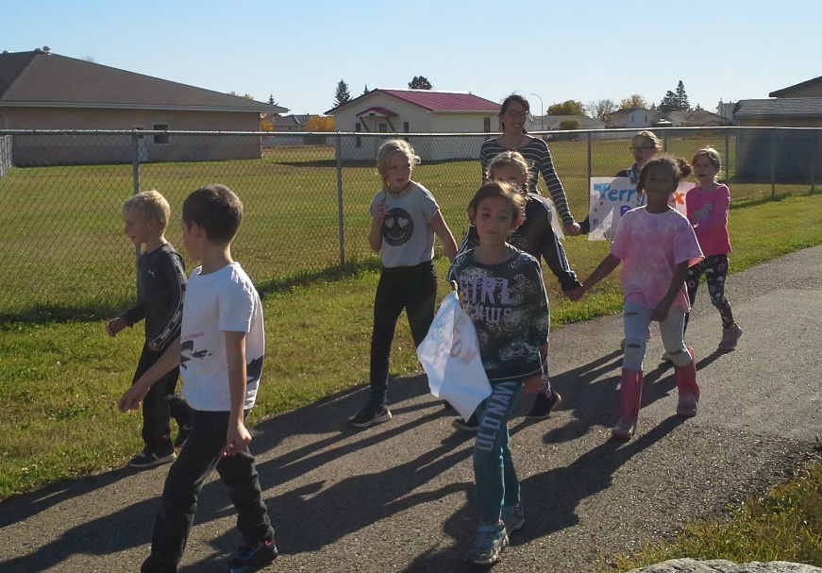

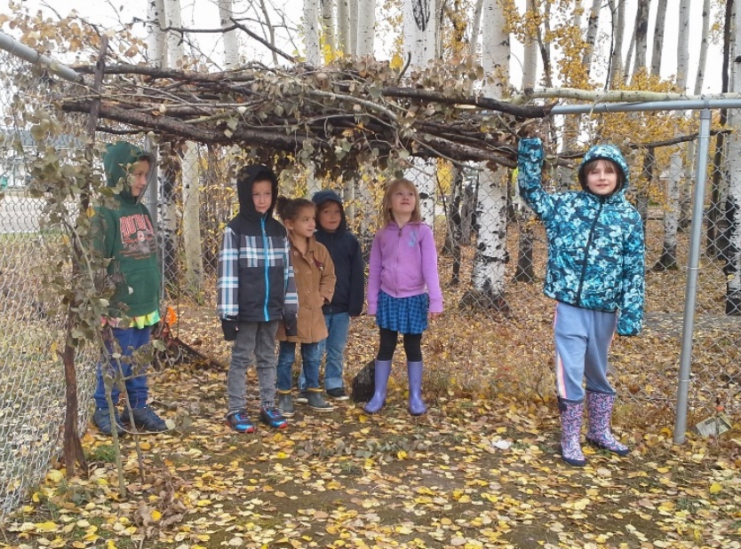
The Fort

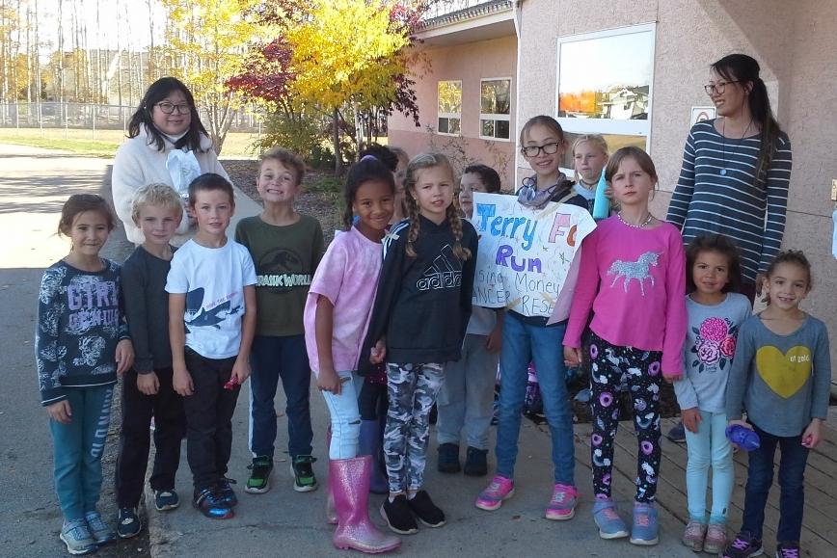

Student Vote

