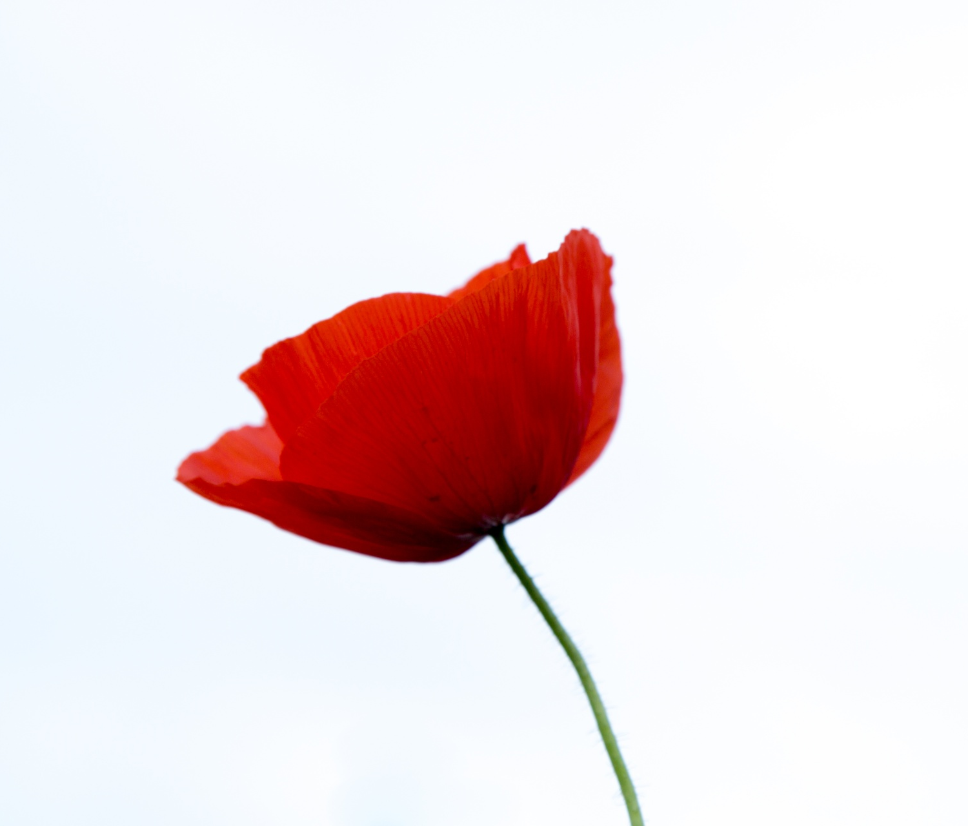

NOVEMBER MEMOS

FROM THE PRINCIPAL

Every month I sit down to write this memo, some months the words come easy, some months I have some passage or point to get down. This month I started, stopped, deleted, paused to read the passages I have in my head. Started again, only to delete again. There are no exact words, just a dozen musings in my head. October was a difficult month; recent school events, wars, etc. left all of us wondering why and what is God’s plan in all this. God is good; He is faithful. This IS the day that God has made. “Know that the LORD, he is God! It is he who made us, and we are his; we are his people, and the sheep of his pasture.” (Psalm 100:3)
Just as October flew by so quickly, so will November. As Remembrance Day approaches, we will take time to remember the importance of sacrifice and the great love that motivates it. Report cards and parent teacher interviews are happening at the end of the month. Our society general meeting is scheduled for November 27th and many exciting things are happening on the board level.
On October 23, Ms. Hannah Loewen began her Educational Assistant practicum in our school; she will mostly assist Mrs. Gerbrandt and Mrs. Krahn but will spend a few hours with the grade 5-9s each week. We are very thankful to have her and are excited to see her grow. She will be in our school for the month of November.
Blessings in Christ,

Ms. Jeffrey
IMPORTANT DATES & EVENTS
Nov 5: Time Change – move your clocks back!
Nov 10: PD Day - no school
Nov 13: Day in Lieu of Remembrance Day - no school
Nov 15: Purdys Chocolates order deadline
Nov 27: Society meeting at HLCA @ 7PM
Nov 28: Report Cards go home
Nov 29 & 30: Parent/Teacher Interviews
A PTI signup sheet will be on the office counter for 2 weeks before interviews for parents to sign up. You may come in or call to sign up. Individual student interview times are set up in 15-minute intervals.

SCHOOL SPORTS
This year we have been registered with ASAA (Alberta Schools Athletic Association). Our official sports coordinator for the year is Miranda Wiebe.

Please Note
Our teachers would appreciate if parents would refrain from texting them between the hours of 9PM and 8AM.
During these hours you can call the school phone and leave a message for them which will be checked and relayed to them in the morning. Thank you for your respect and consideration.

(HLCES) UPDATE FROM THE BOARD:
There will be a Society Meeting Monday, Nov 27th @7:00PM at HLCA. This is open to all HLCA parents. Please remember that to vote on anything at the meeting, you must be a member of the High Level Christian Education Society. Membership applications and Societies Act bylaws are available at the office. If you need more information or have concerns or questions, you will have an opportunity to speak with an HLCES board member who will be present during Parent Teacher Interviews.

ECS

We are continuing to learn and practice the names, shapes and sounds of the alphabet. We will be exploring shapes while continuing to practice our numeracy skills with the numbers 1-10. Socially, students will be continuing to discuss who they are as an individual and what makes them unique from others. We will be using our senses to compare and sort objects based on their properties.
GRADES 1 & 2

This month we’ll be transitioning from Fall to Winter. I look forward to the beautiful snow, but not the colder temperatures. To keep sickness at bay, please ensure your children come dressed appropriately for the weather.
L.A: Grade 1’s will continue practice in making words, building vocabulary, sentence writing, and guided reading. Grade 2’s will begin to edit their own writing, and find and correct writing errors (spelling, punctuation and capitalization). We will begin to write fictional narratives.
Math: Grade 1’s will focus on using different strategies to count to 20, patterns, and 2-9 shapes (geometry). Grade 2’s will be solving word problems, counting numbers to 1000, adding & subtracting. We will also cover patterns, and 2-D shapes.
Science: We will continue to work through our unit on Matter and will continue to learn about objects, materials, and how to choose materials for specific purposes.

Social: We will focus on Chapter 3 – Daily Life: A study on the daily lives of children in Inuit, Acadian, and Prairie communities (i.e., recreation, school).

Bible: We continue to learn about Wisdom and Biblical Truth throughout the year.

GRADES 3 & 4

Math - Grade 4’s have been working on T tables in math and grade 3’s are focusing on differences and parts in total.

Social - We are learning about fossils and why they are important to Alberta.

Science - Our unit this month is lights and shadows.

L.A - we are finishing up our novel study on Owls in the family and continuing to work on our grammar and spelling workbooks.

GRADES 5 & 6

LA – We will continue with our paragraph writing unit and then begin our novel study on Where the Red Fern Grows.
Math - The grade 5s and 6s will begin units on Patterns and identifying pattern rules, from there we will move into multiplication with the grade 5s and the grade 6s will examine divisibility.
Science – After wrapping up our Evidence and Investigation unit, we will begin our unit on Sky Science, which focuses on the night sky and on space.
Social Studies – We are continuing our study of the basic principles of democracy within Canada. We will take a short break to focus on Remembrance Day and enjoy our World War II Museum in a box.
Bible: We will be learning about the following Biblical Truths: 1) Jesus’ death & restoring harmony with God, 2) being created in God’s image, 3) being God’s image-bearers and 4) servanthood & the Church.

GRADES 7 - 9

LA – We will complete our short story unit in the next week and will then move into a unit on functional writing, focusing on the writing process.
Math - Gr 7s – we will begin looking at decimal fractions and from there move into percentages by the end of the month.
Gr 8s – we will spend a little longer on multiplying and dividing fractions, moving into decimal fractions and multiplying and dividing decimals.
Gr 9s – We just began a unit on Rational Numbers and will move into linear relations at the end of the month.
Science – Gr 7s – Wrapping up our structures and forces unit and will move into our unit on heat.
Gr 8/9s – Will complete their unit on Electricity and Electrical technologies, then begin their unit on Space Exploration.
Social Studies – We will take a short break to focus on Remembrance Day and enjoy our World War II Museum in a box. After enjoying our World War II exploration, we will return to our study of Canadian history by looking at the British in North America.
Bible – We will complete our unit on the History of the Bible with a Scribal Project and then a Translation project.

