High Level Christian Academy
“Under His Wings”
“He will cover you with His feathers, and under His wings you will find refuge;
His faithfulness will be your shield and rampart.”
Psalm 91:4

APRIL 2019 NEWSLETTER
FROM THE PRINCIPAL

April is here and with it comes the blessed celebration of Christ’s sacrifice for us; why celebrate? Because Christ came to earth, died on a cross for our sins, and on the third day rose from the grave. His sacrifice conquered the power of sin and death, not just one day in the future, but here and now! His death and resurrection gifts us more than we can ever comprehend. We have amazing hope because of Christ; hope that anchors us in the storms of life, hope that is unshakable, and hope that brings light to dark hours. We have the promise of eternity with God, if we believe in Him.
Jesus said to her, “I am the resurrection and the life. The one who believes in me will live, even though they die; and whoever lives by believing in me will never die. Do you believe this?”
“Yes, Lord,” she replied, “I believe that you are the Messiah, the Son of God, who is to come into the world.” (John 11:25-27)
Jesus speaks these words of promise to Martha as she grieves the death of her brother Lazarus and she has the courage and faith to declare that she believed. Whether Christ would raise her brother from the grave or not she believed Jesus was the Messiah. In the midst of her darkest hours, she clung to the promise of life even in death. We, too, all have this hope because of Christ’s sacrifice on the cross. I pray that Christ’s sacrifice and gift fills your home with the unshakable hope and the brightest of lights. We have hope and confidence for eternity; may we all walk confidently in that hope.

This month at school, while short, is busy. Spring Banquet comes early this year, please pray for our students and staff as we spend much of this week preparing. We will be at the church for rehearsals, Wednesday afternoon, and all day Thursday and Friday. We are having our Easter chapel on April 11th and we will have our Bible day that day also; send your child to school dressed as their favorite Bible character! (I bet no one will guess mine!) On April 12th, the grades 4-9 will participate in Student Vote; this gives them the opportunity to participate in a “mock” vote for our riding. Please don’t forget to vote on Tuesday, April 16th! The future of your parental rights and educational rights within Alberta depend on you exercising your democratic right to vote. Finally, when we return from spring break on the 24th of April, we will get right back into the swing of things with Community Service on the 25th.

I pray that you and your family will have a wonderful, blessed Easter!

Christ is Risen!
He is Risen indeed!
Alisa Jeffrey

Please Pray:
During these next days and weeks, we would ask that you remember some specific members of our school community in prayer. We have extended our condolences to Ms. Chu and her family as they had to say goodbye to her father this week. He has joined our Lord Jesus for which we give God praise. Nevertheless, his passing has come without warning to his family and community so please uphold them in prayer as they accept and adjust. We also want to remember the Neufeld family as they walk through the passing of another year of missing Samantha and the Driedger family as they near this first year mark of missing Mr. Driedger. We pray that the God of all comforts will wrap His arms around each member of these families and that they will experience His love, grace and comfort deeply during this time.

GENERAL INFORMATION:
VISITOR SIGN-IN  Please report at the office before proceeding to any classroom.  STUDENT SIGN-IN  Please stop by the office to sign your child "in" if you are dropping them off after 8:45am or "out" if you are picking them up throughout the day before  3:20pm. This will assist us in knowing which children are on site.  NO PARKING ZONE  We would like to remind parents that the space in front of the school building is a NO PARKING ZONE as per signs posted on the building.  MEMORY VERSES  Please ensure your children are doing their best to memorize these verses; hiding God’s Word in their hearts. An award is given to all students who are able to recite all the verses at the end of the year. | ALLERGIES  We have a student that is allergic to peanuts and peanut products in the ECS/Gr 1 classroom; therefore students in that classroom are not permitted to bring peanut products. Peanut aware student in Gr 7-9.  URSTORE  If you are interested in buying clothing with the school name/crest, or sports apparel with our warriors logo,  please visit our online store. http://urstore.ca/schools/ca/alberta/high-level/hlca-warriors You can customize your order to suit your needs.  SOCIAL MEDIA  Please check out our website @ www.hlcacademy.ca for upcoming events. You can also follow us on Facebook to stay up to date on school happenings, homework and other announcements.

UPCOMING EVENTS
IMPORTANT DATES  (All play practices at @HLEC)  Apr 3: Gr 1-6 Play Practice 12:35-3pm  Apr 4: Whole School Play Practice 9am-3pm  - Students need to bring bag lunches (no heating available) and a water bottle.  Apr 5: Whole School Play Practice 9am-3pm  - Students need to bring bag lunches (no heating available) and a water bottle.  Apr 6: Spring Fundraising Banquet  - Starting at 5:30pm  - @HL Evangelical Free Church | - A reminder for banquet food donations - $60 per family  - We ask that one parent from each family will stay back after the banquet to help with cleanup.  Apr 11: Dress as Favorite Bible Character Day  Apr 12: Last day of classes before Easter break  - Gr 4-9 Student Vote  Apr 19: Good Friday  Apr 21: Easter Sunday  Apr 24: Classes resume  Apr 25: Jump Rope for Heart starts
Apr 25: Tea with Seniors 2:00pm  - We will be needing homemade biscuits for this so if anyone can provide some would be great. Please let the office know. | ATTACHMENTS  - April Calendar  - April Hot Lunch Order Form  HOT LUNCH SNACK SCHEDULE  Apr 11: Jacob Courtoreille  Apr 25: Melissa Driedger

Highlights and Happenings…
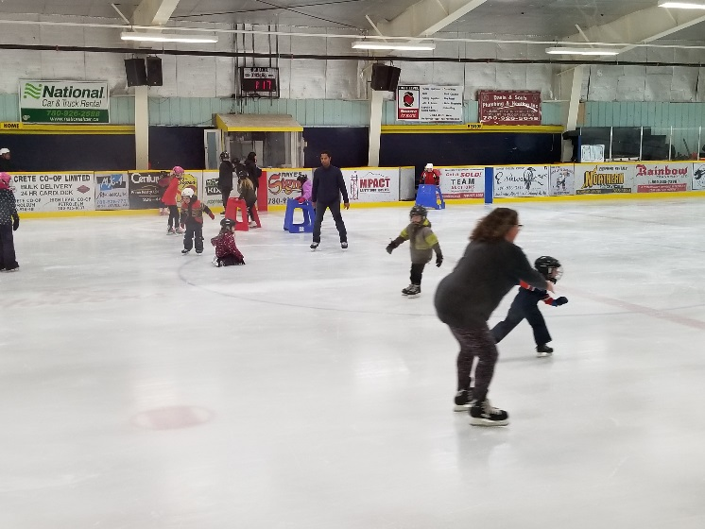
Skating

Science Fair Results
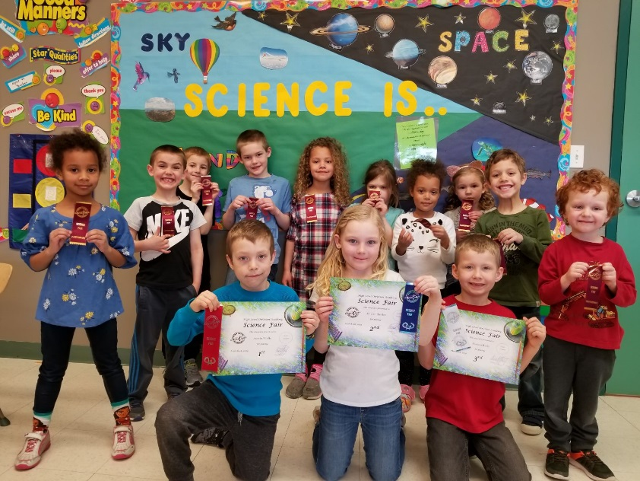
GR 1
- Austin Wolfe
- Khyrin Harder
- Hudson Ruehl
Jaelyn Zorrilla (3rd place tie)
GR 2-3
- Emily Wang / Emery Gerbrandt
- Eliana Gerbrandt / Isabel Gerbrandt
- Sophie Ruehl / Kelaya Wiebe
GR 4-9
- Lexi Lindberg / Ryan Lindberg
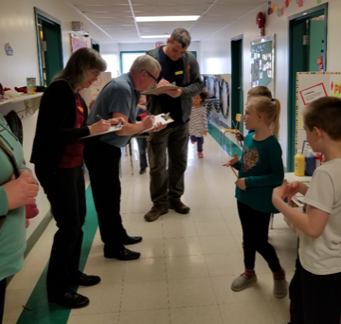
- Jennifer Neufeld / Abby Larocque
Natalie Fehr (2nd place tie)
- Malachi Ruehl / Elijah Gerbrandt

Congratulations to everyone who participated
on an excellent job done!

